

IOTDatabase App

Documentation



## Classes:

View Database: makes HTTP calls, converts them to JSON objects and displays them in listview.

* Spinner that populates a list of search types
* HTTPWorkers that takes in appending string to the URL, parses the received data from the URL call and returns a JSON String
* ConverToApiCommand() converts the item Spinner selection into an URL appending string
* ConvertToJSONObject() converts the JSON String into Object Arrays

Search Database: makes HTTP calls based on search type and search parameters and displays then in a listview.

* HTTP worker that accepts spinner selection item strings, user input and makes HTTP URL call that returns a JSON String

Search_ listview: Fragment that accepts bundles from the Search Database class and populates its listview with an array of JSON objects.

ListView: Fragment that accepts different types of arrays based on selection type and populates the list view accordingly.

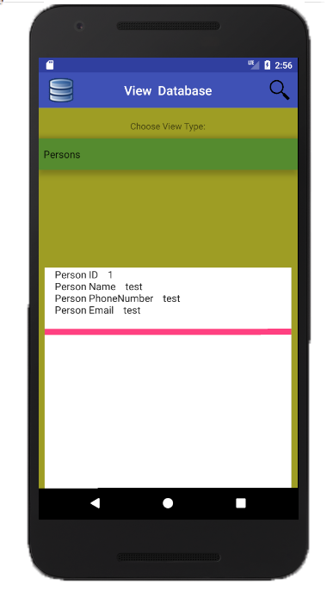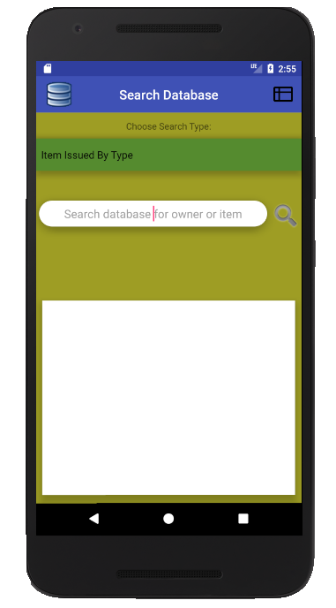

## Design Choices:

Toolbar: Added toolbar classes in View Database and Search Database Oncreate(s) that displays intractable buttons to stream lines the navigation process.